AP Biology Fall Final Study Guide

I skipped Unit 1. Its mostly of chemistry. If you would like to read it yourself =). I would read page 64-65 though. Might be on the test.

This is mostly an overview. I do go in depth on things that I thought were hard/ extensive and will be asked on the test. Sorry if I didn’t cover what you were looking for =(. Mrs. Groch has stated that the questions are pretty general so this is what I come up with!

Unit 2: The Cell

Hierarchy of Life:

Largest

Biosphere- All environments on Earth that supports life, land, water, etc

Ecosystem- All organism in a particular area including non-living things. Eg. African Savanna

Community- All living things in an area. Eg Lions, Zebra, Hippos, etc.

Population- All of the individual species in a community. Eg. Lions

Organism- A single being in a population. Eg. A single lion cub

Organ system- All the systems in the organism. Eg. Circulatory system, Nervous system etc.

Organ- Parts of the organ system that work together. Eg. Brain

Tissue- Parts of an Organ with specific jobs. Eg. Nervous tissue

Cell- tiny microorganisms that make up tissues. Eg. White blood cells, red blood cells.

Organelle- parts inside the cell the help the cell function. Eg. Nucleus

Molecule- A cluster of atoms held together by chemical bonds.

Smallest

Eukaryotic Cell- Cells that have a membrane bound nucleus. Animal/ Plant cells.

Cell Organelles

|  |  |
| --- | --- |
| Organelle | Function |
| Nucleus | Part of the cell where DNA is stored and created. |
| *Nuclear envelope | Membrane enclosing the nucleus. |
| *Nucleolus | Structure in the nucleus where ribosomes are created. |
| *Chromatin | Materials consisting of DNA and proteins; visible in a dividing cell. |
| Plasma membrane | Bilipid layer that surrounds the cell. Acts as a barrier. |
| Ribosomes | Make protein by reading RNA provided by the nucleus. |
| Golgi Apparatus | “warehouse” organizes, sorts, and ships products. |
| Lysosome | Digestive organelles that “eat” and breaks down anything that enters the cell |
| Mitochondria | Makes ATP (cellular respiration) |
| Peroxisome | Help break down fatty acids and detoxifies substances in the body. |
| Microvilli | Projections from the cell that increase cell surface area |
| Cytoskeleton | Reinforces cell shape, helps in movement |
| Centrosome | Region where microtubules begin |
| Flagellum | Long microtubules twirled. Used mostly to help in movement |
| Rough ER |  |
| Smooth ER | Creates lipids and carbs. Detoxifies drugs and poisons and stores calcium ions. |
| Microtubules  These are a family of tubules They are all hollow | Helps with structure and intercellular transport. |
| Intermediate filaments | Shorter than microtubules. Same function. |
| Microfilaments | Thinnest of the 3, more flexible, thinnest of the three |
| Cell wall  These are extras only found in plant cells. | Outer layer that maintains cell’s shape. More rigid than cell membrane. |
| Plasmodesmata | Cytoplasmic channels that are connected to other cells |
| Chloroplast | Photosynthetic organelles that convert light energy to sugar molecules. |
| Central Vacuole | Storage breakdown to waste products and can store large amounts of water. |

Diffusion:

Natural process in which equilibrium need to be met. Substances always **GO DOWN** their concentration gradient.

Osmosis- Diffusion of water.

Hypertonic- cell will lose water. Eg. the surrounding has a high concentration of salt, water will diffuse out of the cell.

Hypotonic- Cell will gain water. Eg. the surrounding has a lower concentration of salt, water will diffuse into the cell.

Active Transport:

Process that uses energy to move solutes across the membrane, an important process that allows substances from outside of the cell enter the cell.

Active transportation involves proteins in the membrane to move the substance over.

Eg. Proton pump that uses ATP to move H+ ions out of the cell to attach with sucrose and diffuse back into the cell. Pg. 137

Enzymes:

Enzymes are used to lower the activation barrier on reactions and speed up reactions. This makes reactions use less amount of energy and hence create less heat.

Enzymes have an active site where a substrate will attach into and cause it to change its shape allowing the enzyme to change the substrate. Eg. on page 155.

I skipped over a lot of stuff here. None of it was part of the review guide from Mrs. Groch so I decided that it was a waste to read it again. If you like to read I skipped all of Ch 8 except enzymes.

Cellular Respiration:

Key terms in this section:

ATP- Adenosine Triphosphate it the form of energy used in our body.

ADP- Adenosine Diphosphate the lack of the phosphate group removes one election making it contain no useable energy

NADH- Think of these as buses (Thanks Mrs. Groch). They carry electrons on them to the ETC.

FADH2- They are a different form of buses but have the same function.

NAD+- These are NADH without elections on them so the are empty buses.

Fermentation- degradation of sugars and other organic fuel that occurs without oxygen.

Aerobic respiration- Oxygen is consumed to created ATP

IMPORTANT EQUATION: **C6H12O6 + 6O2 ↔ 6CO2 + 6H2O + Energy**

All occurs around and inside the mitochondria.

Glycolysis 🡪 Pyruvate Oxidation 🡪 Citric Acid Cycle 🡪 Oxidation Physphorylation: Electron Transport and Chemiosmosis

Glycolysis: Uses energy to create Pyruvate

|  |  |
| --- | --- |
| **Put in** | **Net gain- MOST IMPORTANT** |
| Glucose  4 ATP – 2 ATP used  2 NAD++ 4e- + 4H+ | 2 Pyruvate + 2 H2O  2 ATP  2 NADH + 2 H+ |

Pyruvate Oxidation: When pyruvate enters the mitochondria it is converted into acetyl CoA

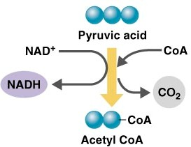

Easier if it’s visual

Citric Acid Cycle or Krebs Cycle:

This is possibly the scariest looking thing in the chapter but a few important things to get out of here.

It has 8 steps where the cycle is simply taking the energy from Acetyl CoA and placing the in NADH or FADH.

The results of the cycle is 6 NADH and 2 FADH2. These both then take the electrons to ETC.

Electron Transport Chain:

In the electron transport chain the electrons from NADH and FADH2 are deposited into proteins.

These electrons then jump from one protein to another causing hydrogen ions to go into the intermembrane space. This is all. The difference between FADH2 and NADH is their docking cite on the ETC.

Chemiosmosis (AKA cootie-catcher):

This is where majority of the ATP is created. There is a rotator protein in the between the intermembrane space and the Mitochondrial Matrix. Here the Hydrogen ions move back into the mitochondrial space.

They go through the rotator protein which has 1 ADP and 1 phosphate group ready to join. The hydrogen ion going through the rotator protein causing it to turn and causes the ADP and Phosphate to join, creating ATP.

This is in the mitochondria’s cell membrane. NEVER GOES INTO THE OUTER CELL MEMBRANE. AGAIN ALWAYS IN THE MITOCHONDRIA!

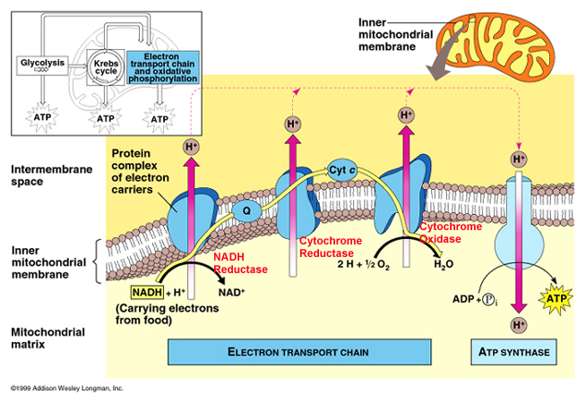

|  |  |
| --- | --- |
| Products | Byproducts |
| 30-32 ATP | CO2 |

**C6H12O6 + 6O2 ↔ 6CO2 + 6H2O + Energy**

Photosynthesis:

Occurs in the mitochondria like structure: Chloroplast.

Chloroplast consists of thylakoids where the creation of energy actually takes place.

The equation **C6H12O6 + 6O2 ↔ 6CO2 + 6H2O + Energy** is now reversed in photosynthesis to **6CO2 + 6H2O + Energy** **↔ C6H12O6 + 6O2** .

As seen here we know that plants require **CO2** and **H2O** to survive. The **Energy** used here is light energy from the sun.

Light Reaction 🡪 Calvin Cycle

Light reaction:

Occurs in the thylakoid membrane where light receptors accept light energy.

The receptors excite an electron and the energy is transferred to another receptor till it finally reaches the special pair of chlorophyll a receptors who finally boost it to the primary electron acceptor.

The special pair of chlorophyll a receptors are dubbed P680 because they absorb light best at wavelength 680.

That is Photosystem II. The electrons are then passed to Photosystem I. The photosystems were named in order of their discovery but Photosystem I occurs first in the process.

From the primary acceptor in Photosystem II the electrons go through a electron transport chain, in which ATP is created, into photosystem II P700, the double receptors best are receiving wavelength 700.

In photosystem I the electron from PS II is attached to a NADPH and sent to the Calvin Cycle.

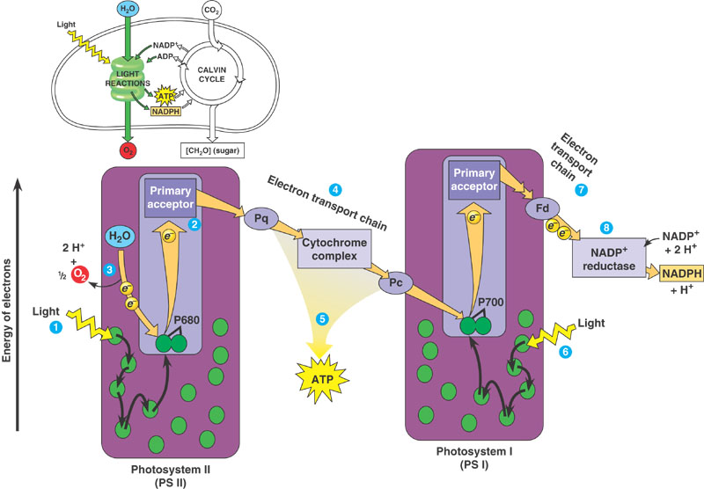

Calvin Cycle:

The function of the Calvin Cycle is to create Glucose and other organic compounds.

Phase 1- Carbon Fixation: 1 CO2 is attached to a Rubisco molecule. Unlike the Citric Acid Cycle where ATP is created, ATP is used in the Kelvin cycle.

Phase 2- Reduction: with the addition of ATP the structure of Rubisco is changed and finally glucose (sugars) is created.

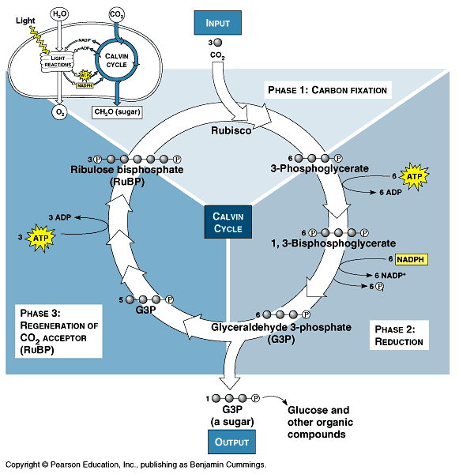

|  |  |
| --- | --- |
| **Input** | **Output** |
| Rubisco  CO2  6 ATP | Sugars  6 NADPH  6 NADP+  6 Phosphates |

ATP Synthase:

The way ATP is created. By products of Photosynthesis II O2 and H+ move to another rotator protein in the membrane where the products go down their gradient, outside the thylakoid, causing the rotator protein to rotate.

Like in the Mitochondria membrane, this rotation causes ADP and Phosphate group to join creating ATP.

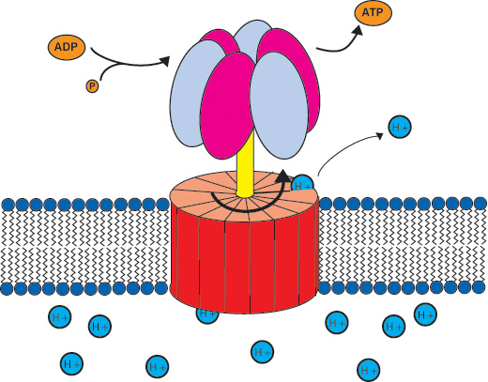

WORKS FOR BOTH PLANTS AND ANIMALS!

C4 Plants:

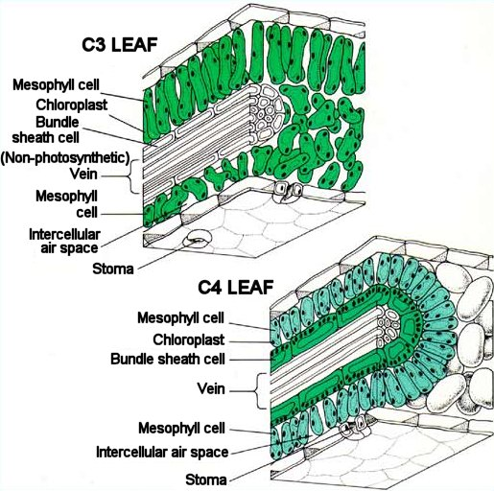

First notice that there is an extra layer, the bundle sheath cell, where C4 plants work.

They prefer a different way rather than the Calvin Cycle.

Step 1. Occurs in mesophyll cells. First PEP carboxylase (enzyme) adds CO2 to PEP forming oxaloacetate. PEP has a higher affinity to CO2 and can use CO2 when CO2 is in much less quantitate.

Step 2. Occurs in Bundle Sheath Cell. 4 carbon product from the first step to step 2.

Step 3. Occurs in Bundle Sheath Cell. Releases CO2 which is sent back into the Calvin Cycle for rubisco to use. Also pyruvate is created which is sent back to the PEP cycle. Then the cells only conduct Photosystem I not Photosystem II.

Steps 1, 2, 3 are on the picture.

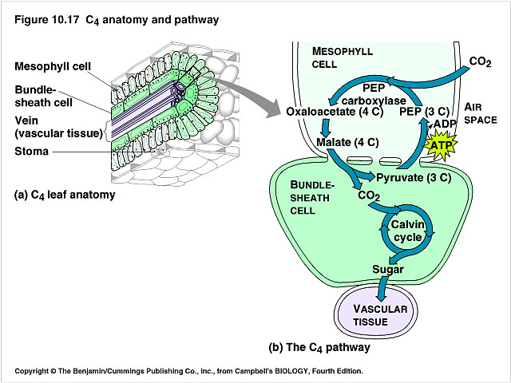

**3**

**2**

**1**

|  |  |
| --- | --- |
| **Input** | **Output** |
| CO2  PEP | Sugar  Pyruvate (used for normal Calvin cycle) |

**Main Difference**: The main difference is that C4 plants use PEP instead of rubisco. The difference is that rubisco requires a larger amount of available CO2 while PEP can be used when CO2 is in smaller amounts.

CAM Plants:

Usually desert plants, these plants open stomata at night while closing them during the day. This helps store water.

CAM: Crassulacean Acid Metabolism

CAM plants take in CO2 at night and store them till the day.

During the day they use the sun energy to produce sugars like normal C4 plants.

While in C4 plants the two steps are done during the same time but in different cells, CAM plants do the steps at different times of the day but in the same cell.

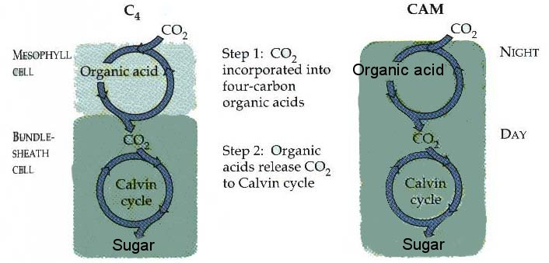

Conclusion:

|  |  |  |
| --- | --- | --- |
| Normal | C4 | CAM |
| Rubisco | PEP | ?? |
| Calvin Cycle | Calvin Cycle  Have extra Bundle-sheath cell | Day and night difference  Occurs in same cell. |

Cell Communication: